TALLER - PLAN DE MEJORAMIENTO FINAL
GRADO: 3°
ASIGNATURA: inglés
DOCENTE: Mayra Yepes
LOGROS:
- Narra, de manera oral objetos, lugares, personas y comunidades, usando oraciones simples.
- Describe, de manera escrita, objetos, lugares, personas y comunidades, usando oraciones simples.
- Responde, de manera oral o escrita, preguntas sencillas sobre textos descriptivos cortos y alusivos a temas conocidos y de clase.
- Intercambia ideas y opiniones sencillas con compañeros y profesores, siguiendo modelos o a través de imágenes.
- Comprende las características de un texto, cuyo propósito es narrar un hecho o expresar ideas, sentimientos o emociones.
- Reconoce los roles de quien produce y de quien interpreta un texto en una situación comunicativa específica.

- What are they doing?
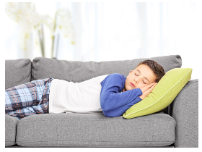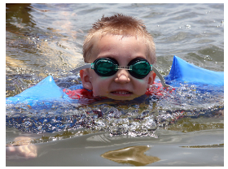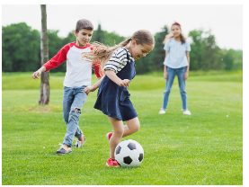
_____________________ ________________ ____________________ ___________________
_____________________ ________________ ____________________ ___________________
_____________________ ________________ ____________________ ___________________
_____________________ ________________ ____________________ ___________________
_____________________ ________________ ____________________ ___________________

- Look at the map and write sentences using the prepositions of places.
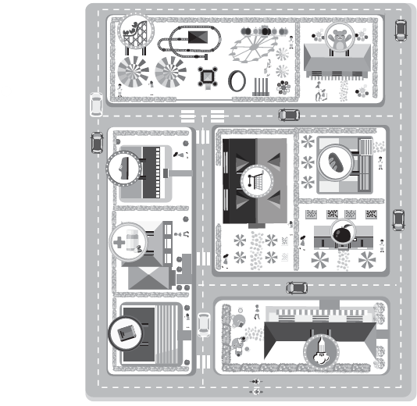
For example: The bakery is next to the market.
- _______________________________________________________________
- _______________________________________________________________
- _______________________________________________________________

- What are they wearing?
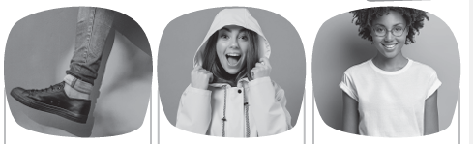
_____________________ ________________ ____________________
_____________________ ________________ ____________________
_____________________ ________________ ____________________
_____________________ ________________ ____________________
_____________________ ________________ ____________________

- Look and match
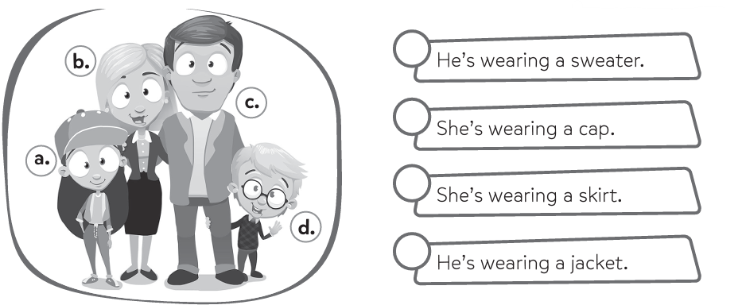
- What time is it?
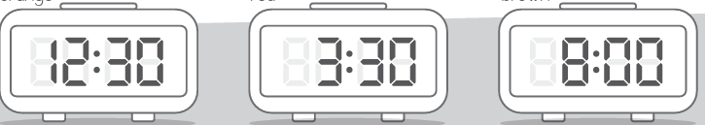
________________________ ______________________ ______________________
- Look and complete with the present continuous.
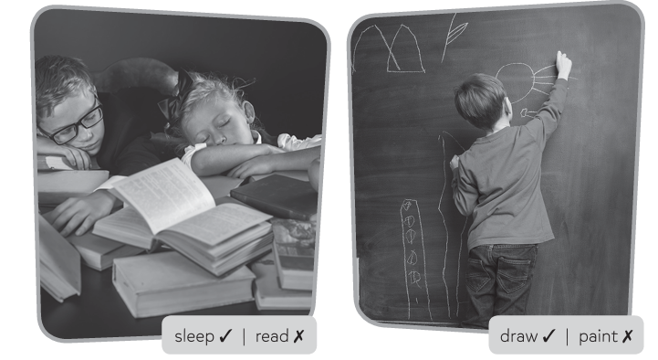
______________________________ ______________________________
______________________________ ______________________________

- Look and answer:
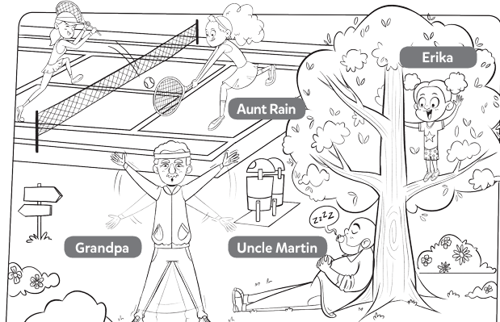

- Is Grandpa reading? ___________________________________
- Is Aunt Rain playing tennis? ___________________________________
- Is Erika climbing a tree? ___________________________________
- Is Uncle Martin reading? ___________________________________
- Read and answer.
- When is Halloween? ______________________________
- When is Easter? _________________________________
- When is Christmas? ________________________________
- When is your mom's birthday? _________________________
- When is your birthday? ________________________________
- When is your friend’s birthday? __________________________
- When is your English teacher’s birthday? ___________________

- Complete with This, That, These, or Those.
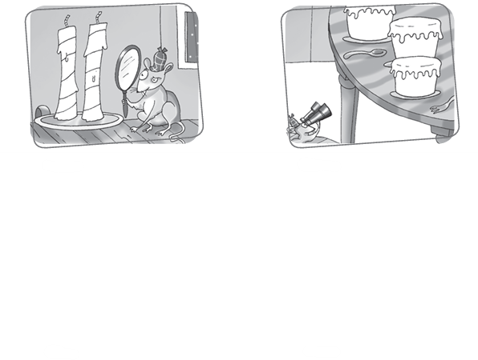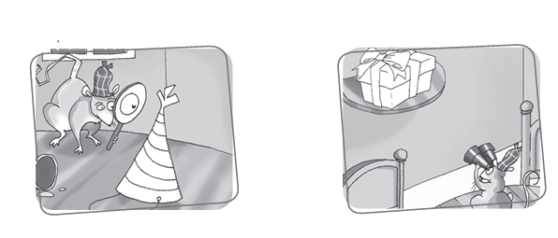
_______ candles. _________ cakes. ________ present. ________ party hat.

